**CYBER SECURITY WEEK 6 ASSIGNMENT (SQL JOIN)**

**OLANREWAJU ADESINA FE/23/10260344**

**Assignment**: Use SQL to connect the ‘machines’ and ‘employees’ table using left join

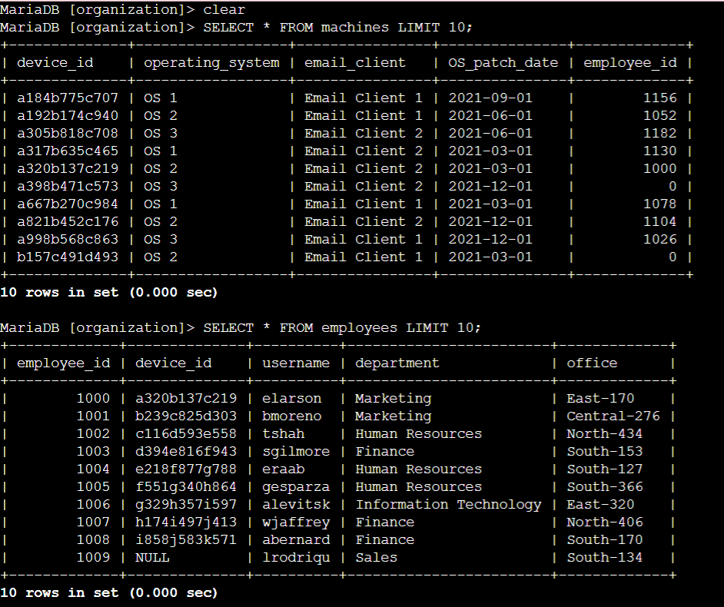

First I checked the columns contained in the ‘machines’ and ‘employees’ table and limit the result to 10 rows using the SQL command SELECT * FROM machines LIMIT 10; and SELECT * FROM employees LIMIT 10;

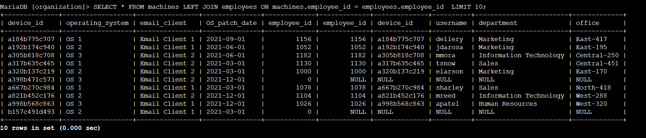

Then I joined the ‘machines’ and ‘employees’ table using left join with the ‘machine’ table as the left table and the ‘employees’ table as the right table in order to return all the records of the ‘machine’ table and records that match on the employee_id column from the ‘employee’ table.

Finally, I used the command SELECT * FROM machines LEFT JOIN employees ON machines.employee_id = employee.employee_id LIMIT 10; to return the records and limit the rows of the returned records to 10.